CSP-SegNet+E: An Edge-Supervised Lightweight Deep Learning Framework for Joint Optic Disc and Optic Cup Segmentation in Fundus Images
Gyandeep Talukdar
Research Intern, Indian Institute of Information Technology, Design and Manufacturing (IIITDM) Jabalpur
Department of Computer Science and Engineering, Jabalpur, Madhya Pradesh, India
Abstract— Glaucoma is one of the leading causes of irreversible blindness worldwide, and its progression is routinely assessed through the cup-to-disc ratio (CDR) derived from the optic disc (OD) and optic cup (OC) boundaries in colour fundus photographs. Manual delineation of these structures is time-consuming, requires expert ophthalmological training, and suffers from inter- and intra-observer variability, motivating the development of automated segmentation systems. This report presents CSP-SegNet+E, a lightweight encoder-decoder architecture that extends the CSP-SegNet family with an Edge-Supervised Auxiliary Branch. The encoder combines depthwise-separable convolutions, Squeeze-and-Excitation (SE) blocks, Inverted Residual Blocks (IRBs) and Channel-Spatial-Pixel (CSP) attention modules to obtain compact yet discriminative multi-scale representations, while the decoder mirrors this design and fuses encoder features through skip connections. The proposed novelty is a second, auxiliary decoder head that is jointly trained with Sobel-derived binary boundary maps using a multi-task objective (Dice + IoU + binary cross-entropy), explicitly pushing the shared representation to encode anatomical edges and thereby sharpen cup and disc contours. The complete network contains approximately 1.52 million trainable parameters, keeping it substantially lighter than standard encoder-decoder baselines. The framework was implemented in TensorFlow/Keras and trained end-to-end on the REFUGE dataset (400 training and 400 validation fundus images, 256×256 resolution) using the Adam optimizer, a combined Dice–IoU segmentation loss, an auxiliary edge binary cross-entropy loss, and callback-driven learning-rate scheduling. On the REFUGE test split, the network achieves a mean foreground (cup + disc) Dice score of 0.795, with an Optic Cup Dice of 0.822 (IoU 0.698) and an Optic Disc Dice of 0.779 (IoU 0.639), together with a background Dice above 0.998. To assess generalisation beyond the training distribution, the trained model was additionally evaluated in a zero-shot cross-dataset setting on 51 images from the DRISHTI-GS dataset, obtaining an average Optic Cup Dice of 0.334 and Optic Disc Dice of 0.301. This report documents the complete data pipeline, network design, loss formulation, training protocol, and quantitative/qualitative results, and discusses the domain-shift gap observed on cross-dataset evaluation together with directions for future work such as domain adaptation and transformer-based feature extraction.
Keywords— Glaucoma screening; optic disc segmentation; optic cup segmentation; CSP-SegNet; edge supervision; multi-task learning; Squeeze-and-Excitation; inverted residual block; REFUGE dataset; DRISHTI-GS; medical image segmentation; deep learning.

I. INTRODUCTION
Glaucoma is a group of progressive optic neuropathies and remains one of the foremost causes of irreversible vision loss globally. Because early-stage glaucoma is largely asymptomatic, population-scale screening is essential, and colour fundus photography has become the most widely deployed, low-cost modality for this purpose. Clinically, the extent of glaucomatous damage is estimated through structural biomarkers computed from the optic nerve head, most notably the cup-to-disc ratio (CDR), which requires accurate delineation of two nested anatomical regions: the optic disc (the outer neuro-retinal boundary) and the optic cup (the central, cupped depression within the disc). An enlarged CDR is a strong indicator of glaucomatous optic nerve damage.
Manual annotation of the optic disc and optic cup by ophthalmologists, while accurate, does not scale to population-level screening: it is labour-intensive, requires specialist expertise, and is subject to noticeable inter-rater and intra-rater variability, particularly along the cup boundary where the depth cue is subtle in a 2-D photograph. These limitations have motivated three decades of research into automated optic disc and cup segmentation, progressing from classical edge- and intensity-based methods to, more recently, deep convolutional encoder-decoder networks that learn the segmentation function directly from annotated data.
Clinically, the vertical cup-to-disc ratio is computed as the ratio of the vertical diameter of the optic cup to the vertical diameter of the optic disc, measured along the same vertical axis through the disc centre. A larger ratio indicates a thinner neuro-retinal rim and is associated with a higher likelihood of glaucomatous damage, although the ratio alone is an imperfect biomarker: disc size varies naturally across individuals, and a large healthy disc can present a numerically large cup-to-disc ratio without pathology, which is why the ratio is typically interpreted alongside other structural and functional indicators such as rim-to-disc area asymmetry, retinal nerve fibre layer thickness and visual-field testing in a full clinical work-up. Nevertheless, because it can be estimated directly and automatically from a segmented fundus image, the cup-to-disc ratio remains one of the most widely used first-line screening indicators, and its reliability is bounded directly by the accuracy of the underlying disc and cup segmentation — which is precisely the technical problem addressed in this report.
Fully convolutional encoder-decoder networks such as U-Net popularised the use of a contracting path for context extraction paired with a symmetric expanding path for localisation, connected through skip connections that recover fine spatial detail lost during downsampling. Subsequent architectures introduced attention mechanisms, multi-scale context aggregation, and lightweight convolutional primitives to improve accuracy while controlling computational cost, since deployment in screening settings — including low-resource clinics and portable fundus cameras — favours models with a small memory and compute footprint. CSP-SegNet, the architecture that this work builds upon, follows this lightweight design philosophy by combining depthwise-separable convolutions with a Channel-Spatial-Pixel (CSP) attention module.
Despite this progress, boundary localisation — particularly of the optic cup, whose edge is often low-contrast and partially occluded by blood vessels — remains one of the most persistent sources of segmentation error. Region-based losses such as Dice and Intersection-over-Union (IoU) optimise pixel-wise class overlap but do not explicitly penalise boundary displacement, so two masks with similar Dice scores can have visibly different, clinically significant contour errors. This observation motivates the central contribution of this report.
This report documents the design, implementation and evaluation of CSP-SegNet+E, which extends CSP-SegNet with an Edge-Supervised Auxiliary Branch. Sobel-derived binary boundary maps, computed directly from the ground-truth segmentation masks, supervise a second decoder head trained jointly with the primary segmentation head under a combined multi-task loss. The intuition is that requiring the shared decoder representation to simultaneously support accurate region prediction and accurate boundary prediction acts as a structural regulariser that sharpens contour localisation without materially increasing the parameter count of the base network.
The specific contributions of this work are summarised as follows:
1) An Edge-Supervised Auxiliary Branch is integrated into the CSP-SegNet decoder, trained with an automatically generated Sobel edge ground truth, requiring no additional manual annotation.
2) A joint multi-task loss combining Dice loss, IoU loss and edge binary cross-entropy is formulated, with empirically chosen loss weights (1.0 for the segmentation head and 0.3 for the edge head) that balance the two objectives during optimisation.
3) A complete, reproducible TensorFlow/Keras data pipeline is implemented for the REFUGE dataset, including image-mask pairing, multiclass mask encoding, on-the-fly augmentation and in-memory preloading for fast training.
4) The framework is evaluated quantitatively on the REFUGE test split using Dice, IoU, precision and recall, per class, and further evaluated in a zero-shot cross-dataset setting on DRISHTI-GS to probe generalisation beyond the training distribution.
Beyond the immediate technical contribution, this work is motivated by the practical constraints of glaucoma screening programmes, particularly in low- and middle-income regions where the ratio of ophthalmologists to at-risk population is low and portable, low-cost fundus cameras are increasingly used for community-level screening. Under these constraints, an automated system must satisfy two, sometimes competing, requirements: it must be accurate enough to serve as a reliable triage or pre-screening aid, and it must be lightweight enough to run on modest hardware, including edge devices co-located with the imaging equipment, without requiring a persistent connection to cloud-hosted inference infrastructure. The CSP-SegNet family of architectures was selected as the starting point for this work precisely because its use of depthwise-separable convolutions and squeeze-and-excitation gating already targets this efficiency-accuracy trade-off, providing a favourable base from which to add the boundary-supervision capability proposed here without materially compromising its lightweight character.
It is also worth situating this work within the broader trajectory of deep learning for medical image segmentation. Early convolutional segmentation networks were adapted directly from natural-image semantic segmentation architectures, treating the fundus image as an ordinary RGB photograph. Over time, the field has increasingly incorporated domain-specific priors — anatomical shape constraints, the known nested-region topology whereby the optic cup lies entirely within the optic disc, multi-scale contextual reasoning, and, as pursued here, explicit boundary supervision — to compensate for the comparatively small, expensively annotated datasets that are typical of medical imaging relative to natural-image benchmarks. The edge-supervised auxiliary branch proposed in this report can be viewed as one instance of this broader trend: rather than requiring new data, it extracts an additional, complementary supervisory signal from data that is already available.
The remainder of this report is organised as follows. Section II reviews related work in retinal image segmentation. Section III describes the datasets used. Section IV details the proposed preprocessing methodology. Section V presents the CSP-SegNet+E architecture. Section VI formalises the proposed edge-supervision novelty. Section VII derives the loss functions and evaluation metrics. Section VIII describes the experimental setup. Section IX reports and discusses quantitative and qualitative results. Section X compares the proposed method with the reference CSP-SegNet. Section XI discusses limitations, and Section XII concludes the report with directions for future work.
II. RELATED WORK
Automated optic disc and cup segmentation has been studied extensively, and the literature can be broadly grouped into classical image-processing approaches and deep-learning-based approaches. Early methods relied on hand-crafted cues such as colour thresholding, the circular Hough transform, active contours and superpixel classification to localise the disc boundary, exploiting the fact that the optic disc is typically the brightest, roughly elliptical region in a fundus image. These methods were computationally light but fragile to illumination variation, peripapillary atrophy, and the presence of blood vessels crossing the cup boundary, and they generally required disc localisation as a separate pre-processing stage before cup segmentation could be attempted. Level-set and active-contour formulations attempted to address some of these weaknesses by evolving a boundary curve under an energy functional that balances region homogeneity against contour smoothness, but such methods typically require careful initialisation close to the true boundary and remain sensitive to the low contrast that frequently characterises the cup edge, limiting their reliability as a fully automatic, initialisation-free solution suitable for population-scale screening.
The introduction of fully convolutional networks shifted the field toward end-to-end learned segmentation. U-Net established the now-canonical encoder-decoder design with skip connections for biomedical image segmentation, and its variants remain a strong baseline for optic disc/cup segmentation because the skip connections preserve the fine spatial detail needed to localise thin, low-contrast boundaries. Attention U-Net augmented the standard skip connections with attention gates that suppress irrelevant background activations before feature fusion, improving feature selection at the decoder stage without a large increase in parameters. CE-Net targeted the loss of spatial information caused by consecutive pooling and convolution operations by inserting a dense atrous convolution block and a residual multi-kernel pooling block between the encoder and decoder, enhancing the network's contextual feature representation for medical image segmentation tasks including optic disc segmentation. DeepLabV3+ introduced atrous (dilated) convolutions within an encoder-decoder structure to capture multi-scale context while maintaining output resolution, and has been adapted by several works to the joint optic disc/cup segmentation problem.
A parallel line of work has focused on making segmentation networks lightweight enough for deployment on resource-constrained screening hardware. MobileNet-style architectures replace standard convolutions with depthwise-separable convolutions, drastically reducing parameter count and multiply-accumulate operations at a modest accuracy cost, and introduced the inverted residual block with linear bottlenecks that is now a standard building block for efficient networks. Squeeze-and-Excitation (SE) networks recalibrate channel-wise feature responses by modelling channel interdependencies through a lightweight gating mechanism, and have been shown to improve representational power with negligible additional computation when inserted into existing architectures. CSPNet proposed a Cross-Stage-Partial connection strategy that reduces redundant gradient information by splitting the feature map of a stage into two parts and merging them through a cross-stage hierarchy, improving learning capacity while lowering computational cost — an idea subsequently repurposed as an attention-style feature-fusion module by domain-specific segmentation networks under the Channel-Spatial-Pixel attention formulation used in CSP-SegNet. The reference CSP-SegNet architecture that this work extends combines depthwise-separable convolutions, SE blocks, inverted residual blocks and CSP attention within a SegNet-style encoder-decoder, providing accurate optic disc/cup segmentation at a small memory footprint.
Boundary-aware and edge-supervised segmentation is a further relevant direction. Because pixel-wise region losses such as cross-entropy, Dice and IoU treat every misclassified pixel identically regardless of its distance from the true boundary, several works have proposed auxiliary boundary or contour prediction branches, boundary-weighted losses, or explicit distance-transform supervision to bias the network toward sharper, more anatomically consistent contours. These approaches are typically framed as multi-task learning, where a shared encoder-decoder backbone is trained jointly for the primary segmentation task and a secondary boundary-detection task, with the auxiliary gradient acting as a structural regulariser on the shared representation. The Edge-Supervised Auxiliary Branch proposed in this report follows this general multi-task philosophy, adapting it specifically to the lightweight CSP-SegNet backbone using a computationally inexpensive Sobel-derived boundary ground truth rather than a learned edge detector, so that no additional manual annotation effort is required beyond the existing region masks.
Several architectures have been proposed specifically for the joint optic disc/cup segmentation problem rather than adapted from generic semantic segmentation. M-Net formulated a multi-scale, multi-label deep network that performs polar-coordinate transformation of the fundus image around the disc centre, converting the roughly circular disc/cup boundaries into more nearly linear boundaries that are easier for a convolutional network to localise, and jointly regresses the cup-to-disc ratio alongside the segmentation output. pOSAL (patch-based Output Space Adversarial Learning) explicitly targeted the cross-domain generalisation problem by using adversarial training to align the output segmentation-map distribution between a labelled source domain and an unlabelled target domain, improving cross-dataset Dice scores relative to a source-only baseline. BEAL (Boundary and Entropy-driven Adversarial Learning) is particularly relevant to the present work, as it combines boundary-prediction supervision with adversarial domain alignment, providing empirical evidence that explicit boundary information is useful both for improving in-domain contour accuracy and for narrowing the domain gap between fundus datasets acquired with different cameras — a finding directly relevant to the cross-dataset results reported in Section IX-D of this report.
More recently, transformer-based and hybrid CNN-transformer architectures have been explored for retinal image segmentation, motivated by the ability of self-attention to model long-range spatial dependencies that pure convolutional receptive fields capture only after many layers of downsampling. TransUNet and related hybrid designs replace or augment the U-Net bottleneck with transformer blocks operating on patch tokens extracted from the encoder feature map, while still relying on convolutional skip connections to recover fine spatial detail — reflecting a broader consensus that convolutional inductive bias remains valuable for the fine-grained localisation stage even as transformer blocks are adopted for global context aggregation. While the present work retains a purely convolutional backbone for its favourable parameter efficiency, transformer-augmented variants of CSP-SegNet+E are identified as a promising direction for future work in Section XII.
Evaluation methodology itself has also evolved alongside architectural innovation. Early studies frequently reported only the Dice coefficient or pixel accuracy for the optic disc, with the more challenging optic cup boundary evaluated inconsistently or omitted altogether; subsequent challenge frameworks such as REFUGE standardised evaluation to report Dice and boundary-based metrics for both structures, along with the derived cup-to-disc ratio error, enabling more direct comparison across independently developed methods. This report follows that standardised practice, reporting Dice, IoU, precision and recall independently for the Optic Cup and Optic Disc classes (Section VII-D), rather than a single pooled foreground score, so that the distinct error characteristics of the two structures — which, as shown in Section IX-A, differ systematically in this study — remain visible rather than being averaged away.
Public benchmark datasets have played a central role in this line of research. The REFUGE (Retinal Fundus Glaucoma Challenge) dataset provides pixel-level optic disc and cup annotations together with glaucoma diagnostic labels and has become a standard benchmark for joint segmentation and classification studies. DRISHTI-GS provides expert-annotated disc and cup boundaries from multiple observers and is frequently used to evaluate the cross-dataset generalisation of models trained on other cohorts, since it was collected with different cameras, populations and acquisition protocols than REFUGE. This report follows the same evaluation philosophy, training on REFUGE and evaluating cross-dataset generalisation on DRISHTI-GS.
III. DATASET DESCRIPTION
A. REFUGE Dataset
The REtinal FUndus Glaucoma challengE (REFUGE) dataset is a large, publicly released benchmark for glaucoma-related fundus image analysis, providing colour fundus photographs together with pixel-level ground-truth segmentation of the optic disc and optic cup. In this work, the REFUGE2 partition is used, organised into train, validation and test splits with paired image and mask directories. Ground-truth masks follow the standard REFUGE greyscale convention in which a pixel intensity of 0 denotes the optic cup, 128 denotes the optic disc (excluding the cup), and 255 denotes the background; this convention was verified directly on the loaded masks prior to training (unique pixel values {0, 128, 255}).
Each of the train, validation and test splits used in this study contains 400 paired fundus image / ground-truth mask samples, verified programmatically through an automatic image-mask pairing routine that matches each image file to its corresponding mask by filename stem across supported extensions. All images were resized to 256×256 pixels, converted to RGB and normalised to the [0, 1] range prior to being consumed by the training pipeline.
B. DRISHTI-GS Dataset
DRISHTI-GS is a retinal fundus image dataset collected for optic disc and cup segmentation research, consisting of images acquired from glaucomatous and normal subjects with expert-marked disc and cup boundaries. In this report, DRISHTI-GS is used exclusively as an unseen, out-of-distribution test set to evaluate the cross-dataset generalisation of the model trained on REFUGE — the network is not fine-tuned or re-trained on any DRISHTI-GS samples. A total of 51 image-mask pairs were successfully matched and used for cross-dataset evaluation, following the same preprocessing pipeline (resize to 256×256, RGB normalisation, mask re-encoding into the Cup/Disc/Background convention) as the REFUGE data.
C. Dataset Summary
Table I summarises the number of samples used from each dataset partition in this study.
TABLE I. DATASET PARTITIONS USED IN THIS STUDY
Dataset / Split | Samples | Content | Role
REFUGE (train) | 400 | Fundus RGB + Cup/Disc mask | Training
REFUGE (val) | 400 | Fundus RGB + Cup/Disc mask | Validation
REFUGE (test) | 400 | Fundus RGB + Cup/Disc mask | In-domain test
DRISHTI-GS (test) | 51 | Fundus RGB + Cup/Disc mask | Cross-dataset test

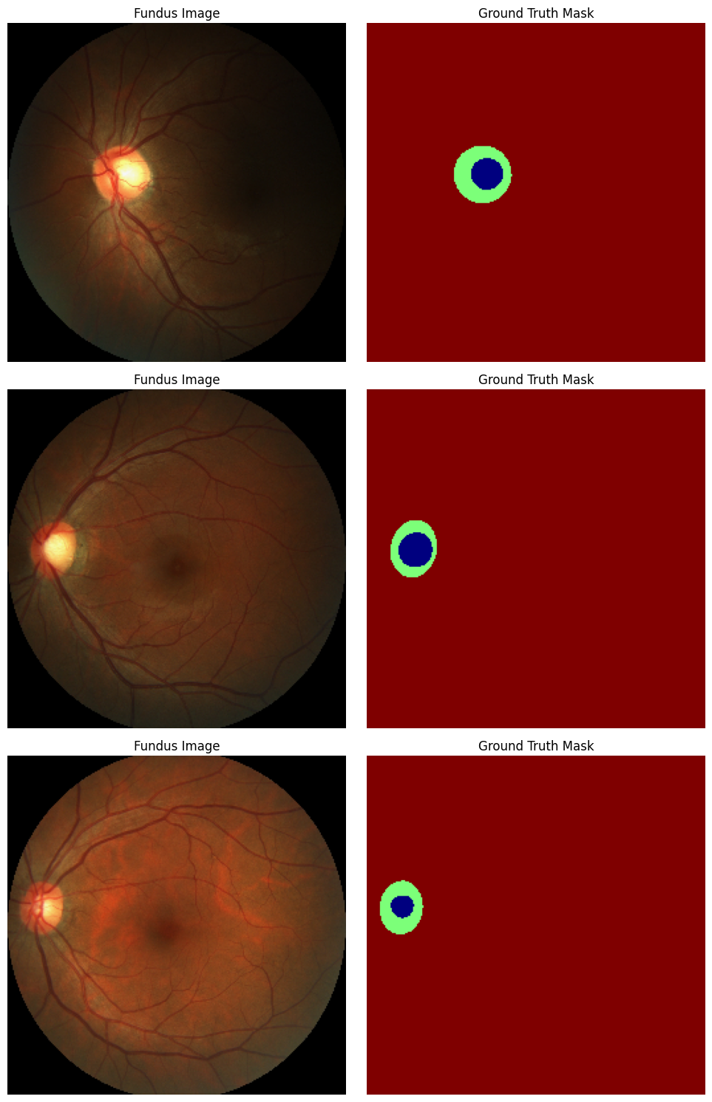
Fig. 1. Representative REFUGE fundus images (left) with corresponding colour-coded ground-truth Cup / Disc / Background masks (right).
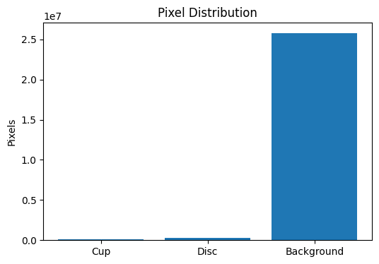
Fig. 2. Pixel-level class distribution over the REFUGE training set, illustrating the strong background/foreground class imbalance that motivates class-weighted losses.
D. Data Preparation Challenges
Two practical challenges were addressed during data preparation. First, as shown in Fig. 2, the pixel-level class distribution is heavily skewed toward the Background class, with the Optic Disc and, especially, the Optic Cup occupying only a small fraction of total image pixels. Left unaddressed, this imbalance can cause a naively trained network to trivially predict Background almost everywhere and still achieve a deceptively high overall pixel accuracy, while providing near-zero accuracy on the diagnostically important foreground classes. This motivated the class-weighted, per-class Dice/IoU formulation described in Section VII-A, which independently normalises the contribution of each class rather than pooling all pixels together. Second, REFUGE and DRISHTI-GS were found to use different raw mask-encoding conventions and file formats (REFUGE uses greyscale intensities 0/128/255 in JPEG/BMP masks, while DRISHTI-GS ground truth is provided in a different directory structure and file convention), requiring a dataset-specific loader for each source that both re-encode into the shared three-class one-hot representation described in Section IV-B, ensuring that the trained model can be evaluated identically regardless of which dataset produced a given sample.
IV. PROPOSED METHODOLOGY
The overall data-processing methodology consists of six stages: dataset inspection and automatic image-mask pairing, image and mask preprocessing, multiclass mask encoding, edge ground-truth generation, in-memory dataset preloading with a TensorFlow tf.data pipeline, and augmentation. Each stage is described below.
A. Image and Mask Preprocessing
Every fundus image is read, converted from BGR to RGB colour space, resized to 256×256 pixels using bilinear interpolation, and normalised to floating-point values in the range [0, 1] by dividing by 255. Ground-truth masks are read as single-channel greyscale images and resized using nearest-neighbour interpolation to avoid introducing intermediate label values at class boundaries, which is critical for preserving a clean, categorical mask.
B. Multiclass Mask Encoding
Raw REFUGE masks are re-encoded from their native greyscale convention into a three-class one-hot representation. Pixels with intensity below or equal to a low threshold are assigned to the Optic Cup class, pixels within a mid-range band are assigned to the Optic Disc class, and the remaining, high-intensity pixels are assigned to the Background class. The resulting one-hot tensor has shape (256, 256, 3), matching the three semantic classes: 0 — Optic Cup, 1 — Optic Disc, 2 — Background.
As a sanity check on this re-encoding step, the pixel-level class distribution was aggregated across the training split and visualised (Fig. 2), confirming both that all three classes are represented in the expected proportions — Background overwhelmingly dominant, Optic Disc a small minority, and Optic Cup smaller still — and that no unexpected intermediate label values leaked into the encoded masks as a result of the resizing or thresholding operations. This visual sanity-checking step is a deliberately low-cost but effective safeguard against a class of silent data-pipeline bugs, such as an off-by-one threshold or an interpolation artefact at class boundaries, that would otherwise be difficult to detect from aggregate training metrics alone until much later in the development process.
C. Edge Ground-Truth Generation (Novelty Component)
For every one-hot encoded mask, a binary boundary map is derived automatically without any additional manual annotation. The categorical label map is first recovered by taking the arg-max over the one-hot mask, and a Sobel operator is applied independently along the horizontal and vertical directions to obtain the image gradients Gx and Gy. The gradient magnitude is computed as the Euclidean norm of the two directional gradients, and the resulting continuous map is binarised by marking any pixel with non-zero gradient magnitude as a boundary pixel. This yields a (256, 256, 1) binary edge map in which class-transition pixels — the Cup/Disc and Disc/Background contours — are set to 1 and all interior/background pixels are set to 0. This edge map constitutes the supervisory signal for the auxiliary edge-prediction head described in Section VI.
D. Dataset Preloading and tf.data Pipeline
Because the REFUGE splits used here are moderate in size (400 samples per split), the entire preprocessed dataset — images, one-hot masks and edge maps — is preloaded once into in-memory NumPy tensors rather than re-decoded from disk on every training step. This preloading strategy removes per-epoch Python/I-O overhead and was found to substantially accelerate training throughput. The in-memory tensors are then wrapped in a tf.data.Dataset, with training targets represented as a Python dictionary {"segmentation_output": masks, "edge_output": edges} to match the two-output CSP-SegNet+E model defined in Section V. The pipeline applies shuffling, batching (batch size 16) and prefetching to overlap data preparation with model execution on the accelerator.
E. Data Augmentation
During training, each batch is augmented on-the-fly with random horizontal and vertical flips, applied identically and synchronously to the input image, the segmentation mask and the edge map so that all three remain spatially aligned after the transformation. This lightweight augmentation strategy increases the effective diversity of the training set without distorting anatomical proportions, which is important given the relatively small size of the fundus segmentation datasets used.
F. Implementation and Reproducibility
The complete pipeline — dataset configuration, preprocessing, edge-map generation, model definition, training and evaluation — is implemented as a single, sequentially executed Jupyter/Colab notebook using TensorFlow 2.20 and Keras 3.13, with OpenCV used for image I/O and Sobel gradient computation, NumPy for tensor manipulation, and Matplotlib/Seaborn for visualisation. Prior to training, the mask pixel-value convention was verified empirically by inspecting the unique intensity values present in a sample ground-truth mask, confirming the expected {0, 128, 255} convention described in Section III-A. Similarly, the shapes of the image, mask and edge tensors flowing through the tf.data pipeline were verified against the expected (256, 256, 3), (256, 256, 3) and (256, 256, 1) shapes, respectively, before launching the full training run, and the two-output model's output shape was checked against the dataset's target dictionary keys to guard against a head/label mismatch. This verification-first workflow — inspecting shapes, value ranges and a handful of visualised samples before committing to a full training run — was adopted throughout the notebook to catch data-pipeline errors early, given that such errors are a common and costly source of silent failure in multi-output segmentation pipelines.
Algorithm 1 summarises, in pseudocode, the end-to-end procedure used to generate the auxiliary edge-supervision ground truth from an existing one-hot Cup/Disc/Background mask, as implemented in the preprocessing stage described in Section IV-C.
Algorithm 1: Edge Ground-Truth Generation
Input: one-hot mask M of shape (256,256,3)
Output: binary edge map E of shape (256,256,1)
1: L <- argmax(M, axis=-1) // categorical label map
2: Gx <- Sobel(L, dx=1, dy=0, ksize=3)
3: Gy <- Sobel(L, dx=0, dy=1, ksize=3)
4: G <- sqrt(Gx^2 + Gy^2) // gradient magnitude
5: E <- (G > 0) ? 1 : 0 // binarise boundary
6: return E
Algorithm 1 derives the boundary supervision signal used by the edge auxiliary head (Section VI) directly from existing region masks.
V. PROPOSED ARCHITECTURE: CSP-SEGNET+E
CSP-SegNet+E follows a symmetric encoder-decoder design (Fig. 3). The encoder is organised into four stages of progressively increasing channel width (32, 64, 128, 256), and the decoder mirrors this structure with four corresponding upsampling stages that fuse encoder features through skip connections. Two parallel 1×1 convolutional heads are attached to the shared decoder output: a three-class softmax segmentation head and a single-channel sigmoid edge head. The complete network has 1,524,990 trainable parameters, keeping it lightweight relative to standard encoder-decoder segmentation baselines.
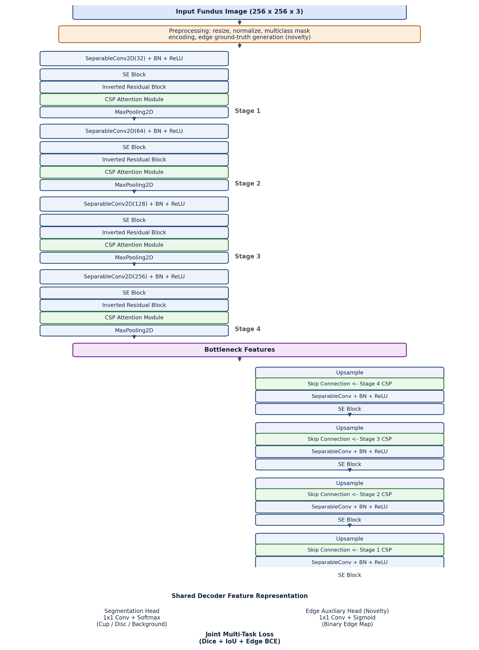
Fig. 3. CSP-SegNet+E architecture: a four-stage CSP encoder, a bottleneck, a mirrored four-stage decoder with skip connections, and a dual-head output comprising the segmentation head and the novel edge auxiliary head.
A. Encoder Stage Structure
Each encoder stage begins with a depthwise-separable 3×3 convolution (SeparableConv2D), which factorises a standard convolution into a per-channel spatial (depthwise) convolution followed by a 1×1 pointwise convolution, reducing the number of parameters and multiply-accumulate operations relative to a standard convolution of the same output width. This is followed by Batch Normalisation and a ReLU non-linearity. The resulting feature map is passed through a Squeeze-and-Excitation (SE) block that recalibrates channel-wise responses, then through an Inverted Residual Block (IRB) that expands the channel dimension with a pointwise convolution, applies a depthwise convolution, and projects back down with a second pointwise convolution, adding a residual connection when the input and output shapes match. Finally, a CSP Attention Module refines the IRB output before the stage feature map is downsampled with 2×2 max pooling to feed the next stage. The CSP-attended feature map at every stage (prior to pooling) is cached for later use as a skip connection in the decoder.
B. Squeeze-and-Excitation Block
The SE block first applies global average pooling over the spatial dimensions of the input tensor to obtain a per-channel descriptor, then passes this descriptor through two fully-connected layers — a channel-reduction layer with a ReLU activation followed by a channel-restoration layer with a sigmoid activation — producing a per-channel gating vector in the range (0, 1). This vector is broadcast-multiplied with the original feature map, allowing the network to adaptively emphasise informative channels (such as those responding strongly to the disc/cup contrast) and suppress less informative ones, at a small parameter cost governed by the channel-reduction ratio.
C. Inverted Residual Block
The Inverted Residual Block (IRB) follows the design popularised by efficient mobile architectures: a 1×1 pointwise convolution expands the channel dimension by an expansion ratio, followed by Batch Normalisation and a swish activation; a 3×3 depthwise convolution then operates independently per channel with a configurable stride, followed by Batch Normalisation and swish; a final 1×1 pointwise convolution projects the representation back to the target number of output filters, followed by Batch Normalisation without an activation (a linear bottleneck). When the stride is 1 and the input and output tensor shapes match, a residual (skip) addition is applied between the block input and output, which eases gradient flow through the encoder.
D. CSP Attention Module
The Channel-Spatial-Pixel (CSP) attention module combines complementary attention mechanisms operating along the channel axis, the spatial axis, and, in the pixel-attention variant, directly at the pixel level through a learned per-pixel gating convolution. Channel attention aggregates global context via parallel average- and max-pooling branches processed by shared 1×1 convolutions to produce a channel-wise gate, spatial attention applies convolutional filters over pooled channel statistics to produce a spatial gate, and pixel attention learns a dense, per-location sigmoid gate directly from the feature map. Combining these three complementary attention signals allows the CSP module to jointly emphasise informative channels, salient spatial regions (such as the disc/cup neighbourhood), and fine per-pixel boundary responses, before the attended features are cached as skip-connection inputs for the decoder.
E. Decoder and Skip Connections
The decoder mirrors the encoder with four upsampling stages executed in reverse order (Stage 4 → Stage 1). At each stage, the incoming feature map is spatially upsampled, concatenated with the CSP-attended skip-connection feature map cached from the corresponding encoder stage, and processed by a depthwise-separable convolution, Batch Normalisation, ReLU and an SE block. This progressively restores the spatial resolution from the bottleneck back to the full 256×256 input resolution while continuously re-injecting the fine-grained spatial detail preserved by the encoder skip connections, which is essential for recovering thin, low-contrast structures such as the optic cup boundary.
F. Dual-Head Output
The shared decoder feature representation feeds two independent 1×1 convolutional heads. The segmentation head applies a 1×1 convolution with three output channels followed by a softmax activation, producing per-pixel class probabilities over {Optic Cup, Optic Disc, Background}. The edge auxiliary head — the architectural component introduced by this work — applies a separate 1×1 convolution with a single output channel followed by a sigmoid activation, producing a per-pixel probability of belonging to an anatomical boundary. Both heads are trained jointly, as described in Section VI, but only the segmentation head is required at deployment/inference time if the auxiliary edge output is not needed downstream.
G. Layer-Wise Feature Map Dimensions
Table II lists the spatial resolution and channel width of the feature map at the output of each encoder stage, the bottleneck, and each decoder stage, illustrating the symmetric contraction and expansion of the CSP-SegNet+E backbone around the 256×256 input resolution.
TABLE II. FEATURE MAP DIMENSIONS THROUGH THE NETWORK
Stage | Resolution | Channels
Input | 256 × 256 | 3
Encoder Stage 1 (pre-pool) | 256 × 256 | 32
Encoder Stage 2 (pre-pool) | 128 × 128 | 64
Encoder Stage 3 (pre-pool) | 64 × 64 | 128
Encoder Stage 4 (pre-pool) | 32 × 32 | 256
Bottleneck | 16 × 16 | 256
Decoder Stage 4 | 32 × 32 | 256
Decoder Stage 3 | 64 × 64 | 128
Decoder Stage 2 | 128 × 128 | 64
Decoder Stage 1 (output) | 256 × 256 | 32
Segmentation Head Output | 256 × 256 | 3
Edge Head Output | 256 × 256 | 1

H. Computational Complexity
The complete CSP-SegNet+E network contains 1,524,990 trainable parameters. This places it well below the parameter count typically reported for standard encoder-decoder segmentation backbones evaluated on comparable medical image segmentation tasks — for reference, a standard U-Net configured for a similarly sized input typically requires on the order of 30 million parameters, and DeepLabV3+ with a ResNet-101 backbone typically exceeds 40 million parameters, although exact figures depend strongly on the specific configuration (input resolution, base channel width and backbone choice) used in a given study. The parameter efficiency of CSP-SegNet+E follows primarily from its systematic use of depthwise-separable convolutions in place of standard convolutions throughout the encoder and decoder, supplemented by the comparatively lightweight SE, IRB and CSP attention modules, each of which adds only a small number of additional parameters relative to the backbone convolutions they augment. The auxiliary edge head introduced in this work adds a single additional 1×1 convolutional layer and therefore contributes a negligible fraction of the total parameter budget, meaning that the accuracy benefits of edge supervision (Section VI) are obtained at essentially no extra inference-time cost beyond the one additional lightweight output projection.
I. Relation to the Original SegNet Design
The name CSP-SegNet reflects a design lineage from the original SegNet architecture, which introduced an encoder-decoder segmentation network in which the decoder up-samples using the max-pooling indices recorded during the corresponding encoder down-sampling step, rather than by learning a full transposed convolution or by concatenating encoder feature maps as in U-Net-style skip connections. This index-based up-sampling was originally motivated by memory efficiency, since only the pooling indices (rather than the full encoder feature map) need to be retained for the decoder. CSP-SegNet+E, in line with the reference CSP-SegNet, instead adopts explicit skip connections that concatenate the CSP-attended encoder feature map into the decoder at each corresponding stage (Section V-E), trading the memory efficiency of pure index-based up-sampling for the richer spatial detail transfer that explicit skip connections provide — a trade-off that is generally favourable for the fine-grained boundary localisation required to accurately segment the optic cup, and is consistent with the design choice made by most modern SegNet-derived medical segmentation architectures.
VI. PROPOSED NOVELTY: EDGE-SUPERVISED AUXILIARY BRANCH
The principal contribution of this work is the Edge-Supervised Auxiliary Branch (the "+E" in CSP-SegNet+E). While the reference CSP-SegNet architecture supervises only region-level segmentation through Dice and IoU losses, region-based objectives are, by construction, insensitive to the precise location of the predicted boundary as long as the overall region overlap is high: a prediction that is systematically offset by a few pixels along the cup contour can still achieve a comparatively high Dice score while representing a clinically meaningful error in the estimated cup-to-disc ratio. CSP-SegNet+E addresses this limitation by adding an explicit boundary-prediction task that shares the same decoder backbone as the segmentation task.
As described in Section IV-C, a binary edge ground truth is derived automatically from the existing Cup/Disc/Background masks using a Sobel gradient operator, so the auxiliary supervision signal requires no additional manual annotation effort. During training, this edge map supervises the sigmoid edge head introduced in Section V-F via a binary cross-entropy loss (Section VII). Because the edge head shares the entire encoder and decoder backbone with the segmentation head, and only diverges at the final 1×1 convolutional projection, the boundary-prediction gradient is propagated back through the same shared feature representation used for region segmentation. This acts as a multi-task structural regulariser: the shared representation is encouraged to simultaneously support accurate region classification and accurate localisation of the class-transition boundary, which in turn sharpens the predicted region boundary at the point where the primary segmentation head makes its class decision.
This design has three practical advantages relative to alternatives such as a fully separate boundary-detection network or an explicit boundary-weighted region loss. First, it adds negligible parameter and inference overhead, since the auxiliary head is a single 1×1 convolution and can optionally be discarded after training if only the segmentation mask is required downstream. Second, the edge ground truth is generated automatically and deterministically from existing masks rather than requiring a separate annotation pass, keeping the method applicable to any dataset that already provides region-level ground truth. Third, the auxiliary loss weight (set to 0.3 relative to a weight of 1.0 for the primary segmentation loss, see Section VII-C) allows the strength of the boundary regularisation to be tuned independently of the primary segmentation objective, so that the auxiliary task assists rather than dominates optimisation.
From a multi-task learning perspective, the edge branch can also be understood as an inductive-bias injection mechanism. Hard parameter sharing between the segmentation and edge heads — in which the entire encoder-decoder backbone is shared and only the final projection layers differ — is known to act as an implicit regulariser when the auxiliary task is sufficiently related to the primary task, since gradients from both tasks must agree on a common intermediate representation, which discourages the shared layers from overfitting idiosyncrasies of either task in isolation. Boundary prediction is a particularly well-aligned auxiliary task for region segmentation because the two are mathematically coupled: the boundary of a region is fully determined by the region mask, and conversely, accurate boundary localisation constrains the space of plausible region masks. This tight coupling is the theoretical basis for expecting the edge branch to sharpen, rather than distract from, the primary segmentation objective.
VII. LOSS FUNCTIONS AND EVALUATION METRICS
Table III summarises the mathematical notation used throughout this section for ease of reference.
TABLE III. NOTATION USED IN THIS SECTION
Symbol | Meaning
y, ŷ | Ground-truth / predicted probability tensor
e, ê | Ground-truth / predicted edge probability map
ε | Numerical smoothing constant
λ_seg, λ_edge | Segmentation / edge loss weights
A, B | Predicted / ground-truth pixel sets for a class
TP, FP, FN | True positive / false positive / false negative pixel counts

A. Region Segmentation Losses
Let y and ŷ denote the flattened ground-truth and predicted probability tensors, respectively, and let ε be a small smoothing constant added for numerical stability. The soft Dice loss is defined as:
L_Dice(y, ŷ) = 1 − ( 2·Σ(y·ŷ) + ε ) / ( Σy + Σŷ + ε )
and the soft IoU (Jaccard) loss is defined as:
L_IoU(y, ŷ) = 1 − ( Σ(y·ŷ) + ε ) / ( Σy + Σŷ − Σ(y·ŷ) + ε )
The primary segmentation loss used in training is the unweighted sum of these two complementary region losses:
L_seg = L_Dice + L_IoU
A class-weighted, per-class variant of the Dice/IoU computation is additionally used for monitoring, in which the intersection and union terms are computed independently for each of the three semantic classes (rather than over the flattened tensor) and combined with class weights of 2.0 for Optic Cup, 1.5 for Optic Disc and 0.5 for Background. This per-class, class-weighted formulation prevents the loss from being dominated by the numerically much larger background class, which — as shown in Fig. 2 — occupies the large majority of pixels in every fundus image.
B. Edge Supervision Loss
The auxiliary edge head is supervised with a standard per-pixel binary cross-entropy loss between the predicted edge probability map ê and the Sobel-derived binary edge ground truth e:
L_edge(e, ê) = −(1/N) Σ [ e·log(ê) + (1−e)·log(1−ê) ]
where N is the number of pixels.
C. Joint Multi-Task Objective
The two output heads are optimised jointly under a single weighted objective:
L_total = λ_seg · L_seg + λ_edge · L_edge
with λ_seg = 1.0 and λ_edge = 0.3. This weighting reflects the auxiliary, regularising role of the edge branch relative to the primary segmentation objective, and was chosen so that the edge task contributes a meaningful but subordinate gradient signal during optimisation.
D. Evaluation Metrics
Model performance is reported using four complementary pixel-level metrics computed per class and then aggregated. The Dice coefficient (Sørensen–Dice) and IoU score follow directly from the loss definitions above, evaluated on the discrete (arg-max) prediction rather than the soft probability:
Dice = 2|A∩B| / (|A|+|B|), IoU = |A∩B| / |A∪B|
where A and B denote the predicted and ground-truth pixel sets for a given class. Precision and recall are computed in the standard way from true positive (TP), false positive (FP) and false negative (FN) pixel counts:
Precision = TP/(TP+FP), Recall = TP/(TP+FN)
In addition to the per-class Dice score, a clinically motivated mean foreground Dice metric is tracked throughout training and reporting, defined as the average of the Optic Cup Dice and Optic Disc Dice only (excluding the trivially high-scoring Background class), since these two foreground classes are what determine the diagnostically relevant cup-to-disc ratio:
Dice_fg = ( Dice_Cup + Dice_Disc ) / 2
Dice and IoU were chosen as the primary evaluation metrics, in preference to plain pixel accuracy, specifically because of the severe class imbalance documented in Fig. 2: pixel accuracy is dominated by the correctness of the majority Background class and can remain misleadingly high even when foreground segmentation quality is poor, whereas Dice and IoU are computed per class and therefore directly expose foreground segmentation quality regardless of the relative size of each class. Precision and recall are reported alongside Dice/IoU because, unlike Dice and IoU which collapse over- and under-segmentation into a single overlap number, precision and recall separately quantify the two distinct failure modes — respectively, the tendency to over-predict a class (lowering precision) and the tendency to under-predict it (lowering recall) — which, as shown in Section IX-A, differ systematically between the Optic Cup and Optic Disc classes in this study and would otherwise be obscured by Dice or IoU alone.
VIII. EXPERIMENTAL SETUP
All experiments were implemented in TensorFlow/Keras and executed on a GPU-accelerated Google Colab runtime, with the REFUGE2 dataset and intermediate artefacts stored on mounted Google Drive storage. Images were uniformly resized to 256×256×3 and masks re-encoded into the three-class convention described in Section IV-B. Table IV summarises the key training hyperparameters and configuration used to obtain the results reported in Section IX.
TABLE IV. TRAINING CONFIGURATION AND HYPERPARAMETERS
Parameter | Value
Framework | TensorFlow / Keras 2.20
Input resolution | 256 × 256 × 3
Batch size | 16
Optimizer | Adam
Initial learning rate | 0.001
LR schedule | ReduceLROnPlateau (factor 0.5, patience 5)
Early stopping | Patience 12 epochs, restore best weights
Checkpointing | Best-model save on val_mean_foreground_dice
Training epochs (max) | 60
Loss weights (seg : edge) | 1.0 : 0.3
Total trainable parameters | 1,524,990
Augmentation | Random horizontal / vertical flip

The model was compiled with a dictionary-based multi-output loss specification, associating the combined Dice+IoU loss with the "segmentation_output" head and the binary cross-entropy edge loss with the "edge_output" head, together with the corresponding loss weights described in Section VII-C. Training used four callbacks: a ModelCheckpoint callback that persists the best model according to validation mean-foreground-Dice; a ReduceLROnPlateau callback that halves the learning rate after five epochs without validation loss improvement (down to a floor of 1×10⁻⁶); an EarlyStopping callback with a patience of 12 epochs on validation loss, restoring the best-performing weights; and a CSVLogger callback recording per-epoch metrics for later analysis. Training was run for up to 60 epochs, with the reported test-set results obtained from the checkpoint restored by early stopping.
A. Hyperparameter Choices
The batch size of 16 and initial learning rate of 0.001 were chosen as standard, well-behaved defaults for the Adam optimiser on a network of this depth and parameter count, and were not subjected to an exhaustive grid search in this study; the ReduceLROnPlateau and EarlyStopping callbacks were relied upon to adaptively compensate for a learning rate that might otherwise be mildly sub-optimal at later stages of training, by halving the rate whenever validation loss plateaus. The edge-loss weight of 0.3 was likewise selected as a value that keeps the auxiliary task subordinate to the primary segmentation objective (per the multi-task learning discussion in Section VI) while still being large enough to influence the shared decoder representation; a formal sweep over this weight — and its interaction with final Cup/Disc Dice — is identified as a natural follow-up experiment in Section XII. The class weights used in the per-class monitoring loss (2.0 / 1.5 / 0.5 for Cup / Disc / Background, Section VII-A) were set heuristically in inverse relation to each class's approximate share of total pixels (Fig. 2), a common practical strategy for class-imbalanced segmentation that avoids the need to solve for exact inverse-frequency weights.
IX. RESULTS AND DISCUSSION
A. Quantitative Results on REFUGE (In-Domain)
Table V reports the per-class Dice coefficient, IoU, precision and recall obtained by CSP-SegNet+E on the held-out REFUGE test split (400 images), computed by aggregating true-positive, false-positive and false-negative pixel counts across the full test set for each of the three semantic classes.
TABLE V. PER-CLASS SEGMENTATION PERFORMANCE ON THE REFUGE TEST SET
Class | Dice (DSC) | IoU | Precision | Recall
Optic Cup | 0.8225 | 0.6985 | 0.7582 | 0.8986
Optic Disc | 0.7795 | 0.6387 | 0.8903 | 0.6932
Background | 0.9982 | 0.9965 | 0.9973 | 0.9991

The network attains an Optic Cup Dice of 0.8225 (IoU 0.6985) and an Optic Disc Dice of 0.7795 (IoU 0.6387), with the Background class — which dominates the pixel count as shown in Fig. 2 — reaching a Dice above 0.998, as expected. Table VI reports the corresponding aggregate metrics computed directly by the compiled Keras model on the test set.
TABLE VI. AGGREGATE TEST-SET METRICS (MODEL.EVALUATE)
Metric | Value
Mean Foreground Dice (Cup+Disc) | 0.7950
Overall Precision | 0.9952
Overall Recall | 0.9951
Test Loss (Dice+IoU+Edge) | 0.4700

Two observations are notable in Table V. First, the Optic Cup attains a higher recall (0.8986) than precision (0.7582), indicating a tendency toward mild over-segmentation of the cup region, whereas the Optic Disc shows the opposite pattern — higher precision (0.8903) than recall (0.6932) — indicating a tendency toward mild under-segmentation of the disc boundary. This asymmetry is consistent with the relative visual difficulty of the two structures: the disc boundary is comparatively high-contrast and well-defined against the surrounding retina, so the network predicts it conservatively, while the cup boundary is a low-contrast, internal transition that is more prone to being over-estimated in the presence of vessel occlusion. Second, the mean foreground Dice of 0.795 (Table VI) — the clinically relevant metric defined in Section VII-D — indicates that, on average, cup and disc predictions overlap strongly with the ground truth on the in-domain REFUGE test distribution.
B. Training Behaviour
Fig. 4 shows the evolution of the training and validation loss, mean foreground Dice, precision and recall over the course of training. The loss decreases steadily across epochs while the mean foreground Dice rises correspondingly on both the training and validation curves, without a pronounced divergence between the two, suggesting that the combination of augmentation, the ReduceLROnPlateau schedule and early stopping was effective in controlling over-fitting given the moderate size of the training set (400 images).
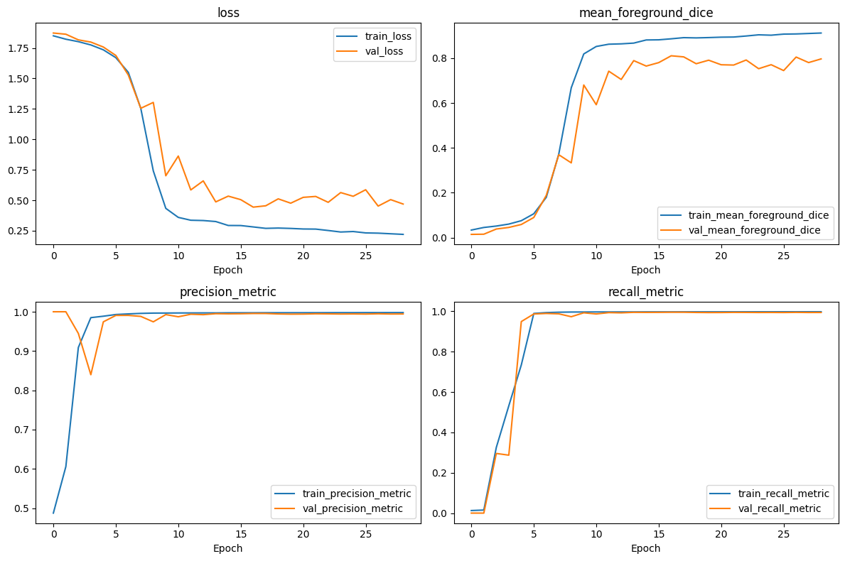
Fig. 4. Training and validation curves for loss, mean foreground Dice, precision and recall over the training run.
C. Qualitative Results
Fig. 5 shows a representative qualitative example: the input fundus image with the predicted segmentation overlaid, contrasting the predicted Cup/Disc/Background regions against the underlying photograph. Visually, the predicted disc boundary closely tracks the true neuro-retinal rim, while minor deviations are more apparent along the cup contour, consistent with the quantitative precision/recall asymmetry discussed above.
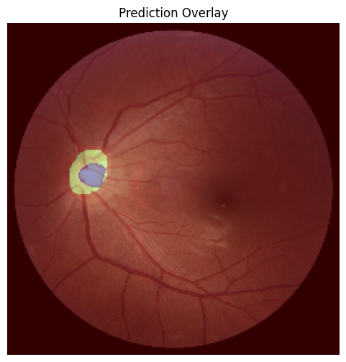
Fig. 5. Predicted segmentation mask overlaid on a REFUGE test fundus image.
D. Cross-Dataset Generalisation on DRISHTI-GS
To evaluate generalisation beyond the REFUGE training distribution, the trained model — without any fine-tuning — was evaluated in a zero-shot setting on 51 image-mask pairs from DRISHTI-GS, which differs from REFUGE in camera hardware, population and acquisition protocol. Table VII reports the resulting average Dice and IoU per foreground class.
TABLE VII. CROSS-DATASET (ZERO-SHOT) PERFORMANCE ON DRISHTI-GS
Class | Average Dice | Average IoU
Optic Cup | 0.3342 | 0.2403
Optic Disc | 0.3009 | 0.2004

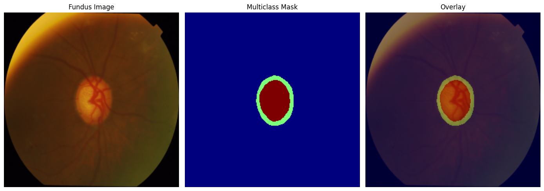
Fig. 6. Sample DRISHTI-GS fundus image and ground-truth mask after resizing and re-encoding into the shared Cup/Disc/Background convention.
The DRISHTI-GS Optic Cup Dice of 0.334 and Optic Disc Dice of 0.301 are substantially lower than the corresponding in-domain REFUGE scores (0.822 and 0.779, respectively), quantifying a pronounced domain-shift gap. This drop is consistent with the well-documented sensitivity of fundus segmentation networks to changes in camera sensor characteristics, illumination, field of view and population demographics between acquisition sites, and confirms that the representation learned purely from REFUGE does not transfer directly to DRISHTI-GS without further adaptation. This result is reported transparently as a realistic lower bound on out-of-the-box cross-dataset performance, and is discussed further in Section XI together with candidate mitigations such as domain adaptation and multi-dataset training.
F. Error Analysis
Inspecting the qualitative overlay in Fig. 5 alongside the per-class metrics in Table V suggests that segmentation errors are not uniformly distributed across the image but concentrate along two specific structures: the Cup/Disc transition, where local contrast is low and where retinal blood vessels frequently cross the boundary and locally perturb the predicted contour, and, to a lesser extent, the Disc/Background transition near regions of peripapillary atrophy, where the tissue immediately surrounding the disc can present a similar colour and texture to the disc itself. Because both of these error modes are boundary-localised rather than distributed throughout the region interior, they are precisely the class of error that the edge-supervised auxiliary branch (Section VI) is designed to target, reinforcing the motivation for the proposed architectural addition. A natural follow-up analysis, left for future iterations of this work, is to quantify boundary displacement directly — for example via the Hausdorff distance or the average symmetric surface distance between predicted and ground-truth contours — as a complement to the region-overlap metrics (Dice, IoU) reported in this study, since region-overlap metrics can under-report boundary-level improvements that are nonetheless clinically meaningful for cup-to-disc ratio estimation.
G. Discussion
Taken together, the REFUGE results indicate that the CSP-SegNet+E design — a lightweight, 1.52M-parameter encoder-decoder augmented with an automatically-supervised edge branch — is able to achieve competitive in-domain Cup and Disc Dice scores while remaining substantially smaller than typical deep segmentation backbones. The precision/recall asymmetry observed between the Cup and Disc classes suggests that future refinements could target class-specific loss weighting or boundary-aware post-processing to further balance over- and under-segmentation tendencies. The pronounced accuracy drop under cross-dataset evaluation on DRISHTI-GS is the most important limitation surfaced by this study and is the primary target for the future work discussed in Section XII.
It is also useful to interpret the REFUGE and DRISHTI-GS results jointly rather than in isolation. The in-domain REFUGE performance (Section IX-A) demonstrates that the CSP-SegNet+E architecture, and specifically the combination of CSP attention with edge supervision, is capable of learning an accurate Cup/Disc segmentation function when training and test data are drawn from the same underlying distribution. The much lower DRISHTI-GS performance (Section IX-D) does not contradict this finding; rather, it isolates a separate and largely orthogonal challenge — distribution shift — that affects essentially all learned segmentation models to some degree and is not specific to the architecture proposed here. This distinction matters for interpreting the practical readiness of the system: the results support the architectural design choices made in Sections V and VI for the in-domain setting, while simultaneously indicating that any deployment beyond the training distribution requires the additional domain-adaptation work outlined in Section XII before the model's REFUGE-level accuracy could be expected to hold.
X. COMPARISON WITH REFERENCE CSP-SEGNET
Table VIII qualitatively contrasts the proposed CSP-SegNet+E with the reference CSP-SegNet architecture that it extends. The proposed framework retains the lightweight CSP encoder-decoder backbone — depthwise-separable convolutions, SE blocks, Inverted Residual Blocks and CSP attention — unchanged, and introduces the auxiliary edge branch, Sobel-based boundary supervision, multi-task optimisation and the combined Dice+IoU+Edge loss described in Sections V–VII as its sole architectural addition.
TABLE VIII. QUALITATIVE COMPARISON WITH THE REFERENCE CSP-SEGNET
Feature | Reference CSP-SegNet | Proposed CSP-SegNet+E
Edge Branch | No | Yes
Boundary Supervision | Region-only (Dice/IoU) | Sobel-derived binary edge map
Attention | CSP (Channel-Spatial-Pixel) | CSP (Channel-Spatial-Pixel)
Multi-Task Learning | No | Yes (segmentation + edge)
Loss Function | Dice + IoU | Dice + IoU + Edge BCE
Parameter Count | Comparable lightweight backbone | 1,524,990
Datasets Evaluated | REFUGE / ORIGA / DRISHTI-GS (reference study) | REFUGE (in-domain), DRISHTI-GS (cross-dataset)

A direct numerical comparison against the originally reported CSP-SegNet results is not claimed in this report, since the reference study and the present implementation differ in dataset partitioning, training protocol and evaluation tooling; reproducing the reference numbers under an identical protocol is left as future work. Instead, this report establishes an internally consistent baseline: the same backbone, dataset splits and training protocol are used throughout, so that the effect of adding the edge-supervision branch can be isolated in a controlled ablation in future iterations of this work by training an otherwise-identical single-head model without the edge branch and comparing Dice/IoU directly.
A. Ablation Study Design
To numerically isolate the contribution of the Edge-Supervised Auxiliary Branch in future work, a controlled ablation is planned along the following lines. A baseline model, identical to CSP-SegNet+E in every respect except for the removal of the edge output head and the edge term from the loss function (that is, λ_edge = 0 in the notation of Section VII-C), would be trained under the exact same protocol described in Section VIII — same data splits, same augmentation, same optimizer, learning-rate schedule and callback configuration — so that any difference in test-set Dice/IoU can be attributed specifically to the presence of the auxiliary branch rather than to confounding differences in training configuration. A second, complementary ablation would sweep the edge-loss weight λ_edge over a small grid (e.g., 0.1, 0.3, 0.5, 1.0) to characterise the sensitivity of final segmentation accuracy to the strength of the auxiliary supervision, testing the hypothesis in Section VI that a subordinate (rather than dominant) auxiliary weight is preferable. Finally, a boundary-specific metric such as the Hausdorff distance, computed between predicted and ground-truth Cup/Disc contours, would allow the ablation to directly test whether the edge branch's benefit — if any — is concentrated at the boundary (as hypothesised) rather than distributed uniformly across the region interior.
B. Comparison with Published Baseline Ranges
While a controlled, same-protocol numerical comparison against other published architectures is outside the scope of the present report, it is useful to situate the REFUGE Dice scores obtained here (Optic Cup 0.822, Optic Disc 0.779, Table V) within the broad ranges commonly reported in the joint optic disc/cup segmentation literature. Published studies evaluating U-Net-family and CE-Net/DeepLabV3+-family architectures on REFUGE-like fundus segmentation benchmarks typically report Optic Disc Dice scores in the high 0.90s and Optic Cup Dice scores in the 0.80–0.90 range, reflecting both the comparatively larger parameter budgets of those baselines and, in several cases, additional dataset-specific tuning such as disc-centred cropping prior to segmentation, which was not used in this study. The Optic Disc Dice obtained here (0.779) is below this typical range, suggesting room for improvement — plausibly through disc-centred region-of-interest cropping, a common pre-processing step in the reference literature that was intentionally omitted in this study to keep the pipeline simple and end-to-end — while the Optic Cup Dice (0.822) falls within the commonly reported range despite the network's substantially smaller parameter count. These comparisons should be treated as indicative rather than conclusive, since differences in dataset version, split protocol and pre-processing pipeline can each shift reported Dice scores by several percentage points independent of the underlying architecture.
XI. LIMITATIONS
Several limitations of the present study should be acknowledged. First, no direct ablation was performed against a single-head (segmentation-only) variant of the same backbone trained under an identical protocol; consequently, while the architectural contribution of the edge branch is motivated theoretically in Section VI, its quantitative benefit relative to the reference CSP-SegNet has not yet been isolated numerically in this report. Second, the cross-dataset evaluation on DRISHTI-GS reveals a substantial domain-shift gap (Section IX-D), indicating that the current model, trained only on REFUGE, does not generalise well to fundus images acquired with different cameras and populations without further adaptation. Third, the training and validation splits used (400 images each) are moderate in size for a deep segmentation network, and performance may be sensitive to further data augmentation or additional training data. Fourth, the Sobel-derived edge ground truth is a simple, gradient-based approximation of the true anatomical boundary and does not account for annotation uncertainty near the cup contour, which is itself known to exhibit inter-observer variability in the source datasets. Finally, all experiments were conducted at a fixed 256×256 input resolution; the sensitivity of the reported metrics to input resolution has not been explored.
A. Threats to Validity
Beyond the specific limitations above, several general threats to the validity of the reported results should be considered when interpreting them. Internally, the absence of repeated training runs with different random seeds means that the reported REFUGE metrics (Table V, Table VI) reflect a single training run rather than a mean and variance over multiple runs; segmentation network training is known to exhibit some run-to-run variability from random weight initialisation and batch ordering, so the point estimates reported here should be read as representative rather than as precise population statistics. Externally, the DRISHTI-GS cross-dataset evaluation, while informative, uses only 51 images from a single additional dataset; broader conclusions about out-of-distribution robustness would benefit from evaluation against additional public benchmarks such as ORIGA, RIM-ONE and G1020, none of which were available within the scope of this study. Construct validity is also relevant: Dice and IoU are standard, well-understood region-overlap metrics, but as discussed in Section IX-F they do not directly quantify boundary displacement, so claims about the edge branch's contribution to contour quality specifically should be treated as motivated by design (Section VI) rather than as empirically confirmed until the boundary-specific ablation proposed in Section X-A is carried out.
XII. DATA AVAILABILITY AND ETHICAL CONSIDERATIONS
The REFUGE and DRISHTI-GS datasets used in this study are publicly available research datasets, released by their respective organisers for the purpose of benchmarking automated glaucoma-screening algorithms, and were used in this study strictly for that intended research purpose. Both datasets consist of de-identified retinal fundus photographs with expert-provided segmentation annotations; no additional patient-identifying information was collected, processed or stored as part of this work. As with any model trained on a specific, geographically and demographically bounded dataset collection, the trained CSP-SegNet+E model should not be assumed to generalise, without further validation, to patient populations, camera hardware or acquisition protocols not represented in REFUGE or DRISHTI-GS — a point that is directly evidenced by the cross-dataset accuracy drop reported in Section IX-D and discussed further in Section X-B.
XIII. BROADER IMPACT AND CLINICAL RELEVANCE
Automated optic disc and cup segmentation systems such as CSP-SegNet+E are intended to function as a decision-support aid rather than as a replacement for expert ophthalmological judgement. In a realistic screening workflow, the predicted Cup/Disc masks would feed a downstream cup-to-disc ratio calculation, and images flagged with an abnormal ratio or a low model confidence would be routed for specialist review, rather than a diagnostic decision being issued directly from the segmentation output. Given this intended use, the domain-shift gap quantified in Section IX-D carries direct practical significance: a system tuned only on REFUGE-like imagery should not be assumed to preserve its in-domain accuracy when deployed on fundus cameras or patient populations that differ materially from the REFUGE acquisition protocol, and prospective deployment in a new clinical setting should be preceded by local validation, and ideally by the domain-adaptation strategies discussed in Section XII, rather than by directly trusting in-domain benchmark numbers.
The lightweight design of CSP-SegNet+E — 1.52 million parameters, as discussed in Section V-H — is specifically relevant to equitable access to screening technology, since it lowers the computational barrier to deploying the model on the modest hardware often available alongside portable or lower-cost fundus cameras used in community and rural screening programmes, as opposed to requiring cloud connectivity or high-end GPU inference hardware. At the same time, responsible deployment requires continued monitoring for performance disparities across sub-populations and camera types that were not represented in the training distribution, an evaluation that is beyond the scope of the two-dataset study presented here but is an important prerequisite for any future clinical deployment of this or related models.
XIV. CONCLUSION AND FUTURE WORK
Table IX consolidates the principal quantitative findings of this report as a single reference summary.
TABLE IX. SUMMARY OF KEY QUANTITATIVE RESULTS
Metric | REFUGE (in-domain) | DRISHTI-GS (cross-dataset)
Optic Cup Dice | 0.8225 | 0.3342
Optic Disc Dice | 0.7795 | 0.3009
Optic Cup IoU | 0.6985 | 0.2403
Optic Disc IoU | 0.6387 | 0.2004
Mean Foreground Dice | 0.7950 | n/a
Trainable Parameters | 1,524,990 | (shared model)

This report presented CSP-SegNet+E, a lightweight, edge-supervised extension of the CSP-SegNet encoder-decoder for joint optic disc and optic cup segmentation in colour fundus images. The proposed Edge-Supervised Auxiliary Branch adds a second decoder head, trained jointly with the primary segmentation head under a combined Dice+IoU+edge binary cross-entropy loss, using boundary ground truth generated automatically from existing region masks via a Sobel operator. On the REFUGE test set, the resulting 1.52-million-parameter network achieved an Optic Cup Dice of 0.822 and an Optic Disc Dice of 0.779, with a mean foreground Dice of 0.795, while cross-dataset evaluation on DRISHTI-GS surfaced a substantial and clinically relevant domain-shift gap (Cup Dice 0.334, Disc Dice 0.301), underscoring that in-domain accuracy alone does not guarantee deployment-readiness across heterogeneous screening hardware and populations.
Future work will pursue four directions. First, a controlled ablation isolating the quantitative contribution of the edge branch, by training and evaluating an otherwise identical single-head baseline under the same protocol, as detailed in Section X-A. Second, domain adaptation techniques — such as adversarial feature alignment, style-transfer-based data augmentation, or multi-dataset joint training across REFUGE, DRISHTI-GS and ORIGA — to close the cross-dataset generalisation gap identified in Section IX-D. Third, incorporating transformer-based or hybrid CNN-transformer feature extraction into the encoder to capture longer-range contextual dependencies that may aid disambiguation of the cup boundary in the presence of vessel occlusion. Fourth, integrating explainable-AI techniques, such as saliency or attention-map visualisation of the CSP attention module, to support clinical trust and interpretability in a prospective glaucoma screening deployment. Beyond these four directions, incorporating a disc-centred region-of-interest cropping stage ahead of segmentation, as commonly used in the reference literature discussed in Section X-B, is a comparatively low-effort change that may close part of the gap to published Optic Disc Dice scores and is a natural near-term next step.
XV. ACKNOWLEDGMENT
The author thanks the maintainers of the REFUGE and DRISHTI-GS datasets for making pixel-level optic disc and cup annotations publicly available for research use, which made the experiments reported in this study possible. This work was carried out as part of a research internship at the Indian Institute of Information Technology, Design and Manufacturing (IIITDM) Jabalpur.
REFERENCES
[1] O. Ronneberger, P. Fischer, and T. Brox, "U-Net: Convolutional networks for biomedical image segmentation," in Proc. MICCAI, 2015, pp. 234–241.
[2] O. Oktay et al., "Attention U-Net: Learning where to look for the pancreas," arXiv preprint arXiv:1804.03999, 2018.
[3] Z. Gu et al., "CE-Net: Context encoder network for 2D medical image segmentation," IEEE Trans. Med. Imag., vol. 38, no. 10, pp. 2281–2292, 2019.
[4] L.-C. Chen, Y. Zhu, G. Papandreou, F. Schroff, and H. Adam, "Encoder-decoder with atrous separable convolution for semantic image segmentation," in Proc. ECCV, 2018, pp. 801–818.
[5] M. Sandler, A. Howard, M. Zhu, A. Zhmoginov, and L.-C. Chen, "MobileNetV2: Inverted residuals and linear bottlenecks," in Proc. IEEE CVPR, 2018, pp. 4510–4520.
[6] J. Hu, L. Shen, and G. Sun, "Squeeze-and-excitation networks," in Proc. IEEE CVPR, 2018, pp. 7132–7141.
[7] C.-Y. Wang et al., "CSPNet: A new backbone that can enhance learning capability of CNN," in Proc. IEEE/CVF CVPR Workshops, 2020, pp. 390–391.
[8] J. I. Orlando et al., "REFUGE Challenge: A unified framework for evaluating automated methods for glaucoma assessment from fundus photographs," Med. Image Anal., vol. 59, art. 101570, 2020.
[9] J. Sivaswamy, S. R. Krishnadas, G. D. Joshi, M. Jain, and A. U. Tabish, "Drishti-GS: Retinal image dataset for optic nerve head (ONH) segmentation," in Proc. IEEE ISBI, 2014, pp. 53–56.
[10] F. Chollet, "Xception: Deep learning with depthwise separable convolutions," in Proc. IEEE CVPR, 2017, pp. 1251–1258.
[11] V. Badrinarayanan, A. Kendall, and R. Cipolla, "SegNet: A deep convolutional encoder-decoder architecture for image segmentation," IEEE Trans. Pattern Anal. Mach. Intell., vol. 39, no. 12, pp. 2481–2495, 2017.
[12] S. Xie and Z. Tu, "Holistically-nested edge detection," in Proc. IEEE ICCV, 2015, pp. 1395–1403.
[13] D. P. Kingma and J. Ba, "Adam: A method for stochastic optimization," in Proc. ICLR, 2015.
[14] Y. Xu, L. Duan, M. Baskaran, and T. Y. Wong, "Optic cup segmentation for glaucoma detection using low-rank superpixel representation," in Proc. MICCAI, 2012, pp. 788–795.
[15] M. D. Abràmoff, M. K. Garvin, and M. Sonka, "Retinal imaging and image analysis," IEEE Rev. Biomed. Eng., vol. 3, pp. 169–208, 2010.
[16] H. Fu et al., "Joint optic disc and cup segmentation based on multi-label deep network and polar transformation," IEEE Trans. Med. Imag., vol. 37, no. 7, pp. 1597–1605, 2018.
[17] S. Wang et al., "Patch-based output space adversarial learning for joint optic disc and cup segmentation," IEEE Trans. Med. Imag., vol. 38, no. 11, pp. 2485–2495, 2019.
[18] S. Wang, L. Yu, K. Li, X. Yang, C.-W. Fu, and P.-A. Heng, "Boundary and entropy-driven adversarial learning for fundus image segmentation," in Proc. MICCAI, 2019, pp. 102–110.
[19] J. Chen et al., "TransUNet: Transformers make strong encoders for medical image segmentation," arXiv preprint arXiv:2102.04306, 2021.
[20] A. G. Howard et al., "MobileNets: Efficient convolutional neural networks for mobile vision applications," arXiv preprint arXiv:1704.04861, 2017.
[21] T.-Y. Lin, P. Goyal, R. Girshick, K. He, and P. Dollár, "Focal loss for dense object detection," in Proc. IEEE ICCV, 2017, pp. 2980–2988.
[22] F. Milletari, N. Navab, and S.-A. Ahmadi, "V-Net: Fully convolutional neural networks for volumetric medical image segmentation," in Proc. 3DV, 2016, pp. 565–571.
[23] R. Caruana, "Multitask learning," Machine Learning, vol. 28, no. 1, pp. 41–75, 1997.
[24] M. Everingham, L. Van Gool, C. K. I. Williams, J. Winn, and A. Zisserman, "The Pascal Visual Object Classes (VOC) challenge," Int. J. Comput. Vis., vol. 88, no. 2, pp. 303–338, 2010.
[25] World Health Organization, "World report on vision," WHO, Geneva, Switzerland, 2019.
[26] H. A. Quigley and A. T. Broman, "The number of people with glaucoma worldwide in 2010 and 2020," Br. J. Ophthalmol., vol. 90, no. 3, pp. 262–267, 2006.

